EXPLORATORY ANALYSIS OF RAINFALL DATA IN INDIA FOR AGRICULTURE.

**Team ID: PNT2022TMID50196**

WAY TO INSTALL ANACONDA

**STEP 1**: **Download** the Anaconda.



**STEP 2**: **Install** the Anaconda.

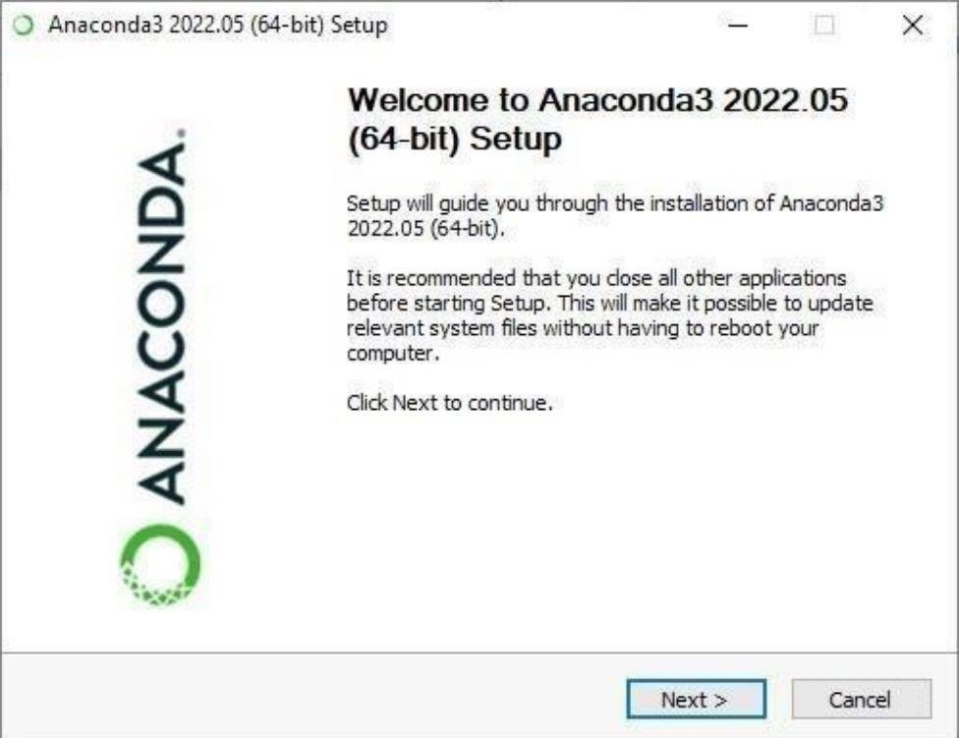

**STEP 3**: Click on **I Agree.**

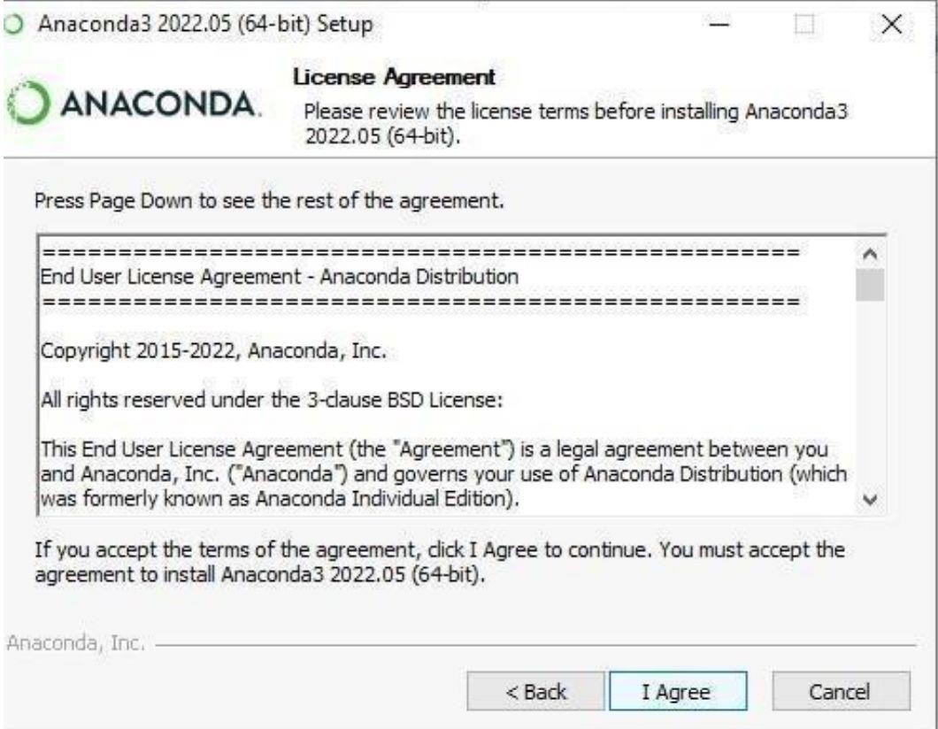

**STEP 4**: Choose the **Installation Location.**

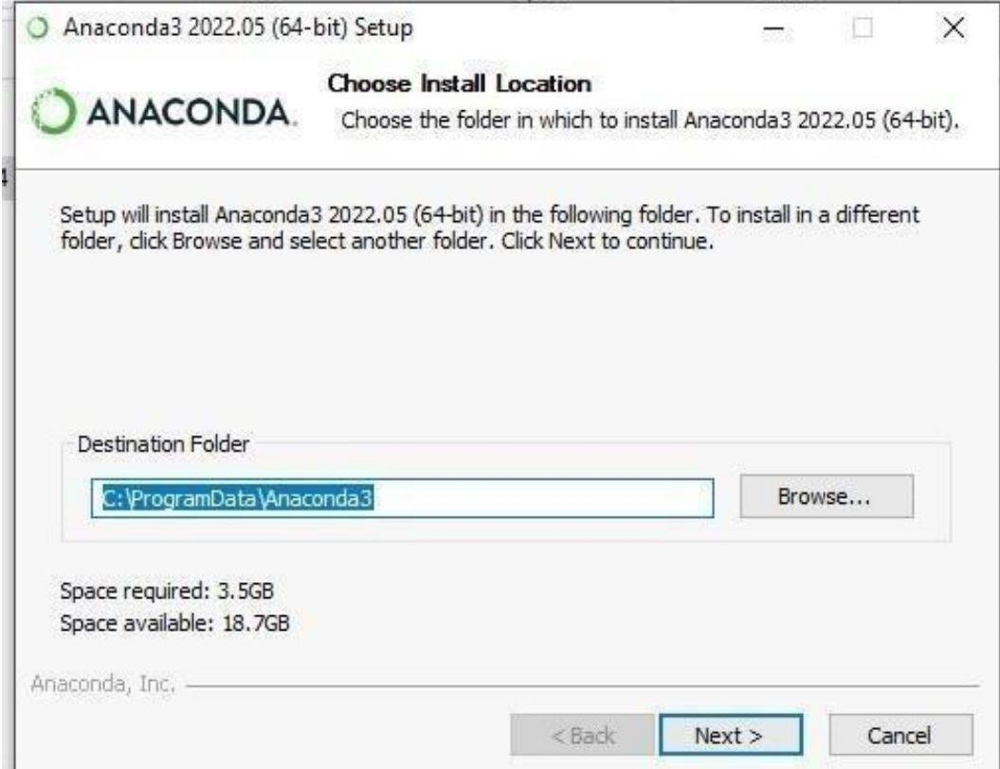

**STEP 5**: Installing the Requiring **packages**.

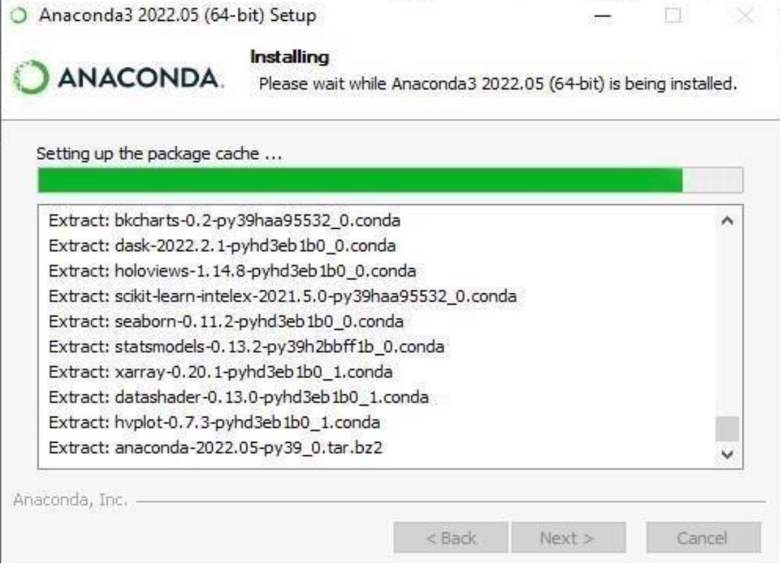

**STEP 6**: Setting up the **base environment**.

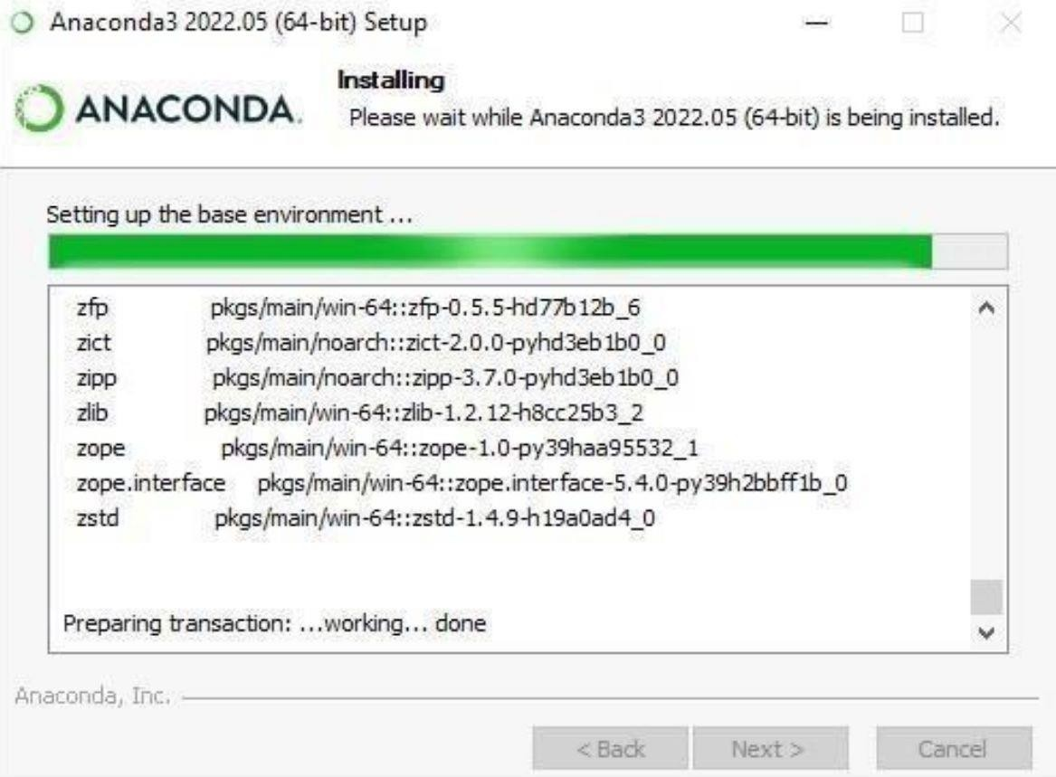

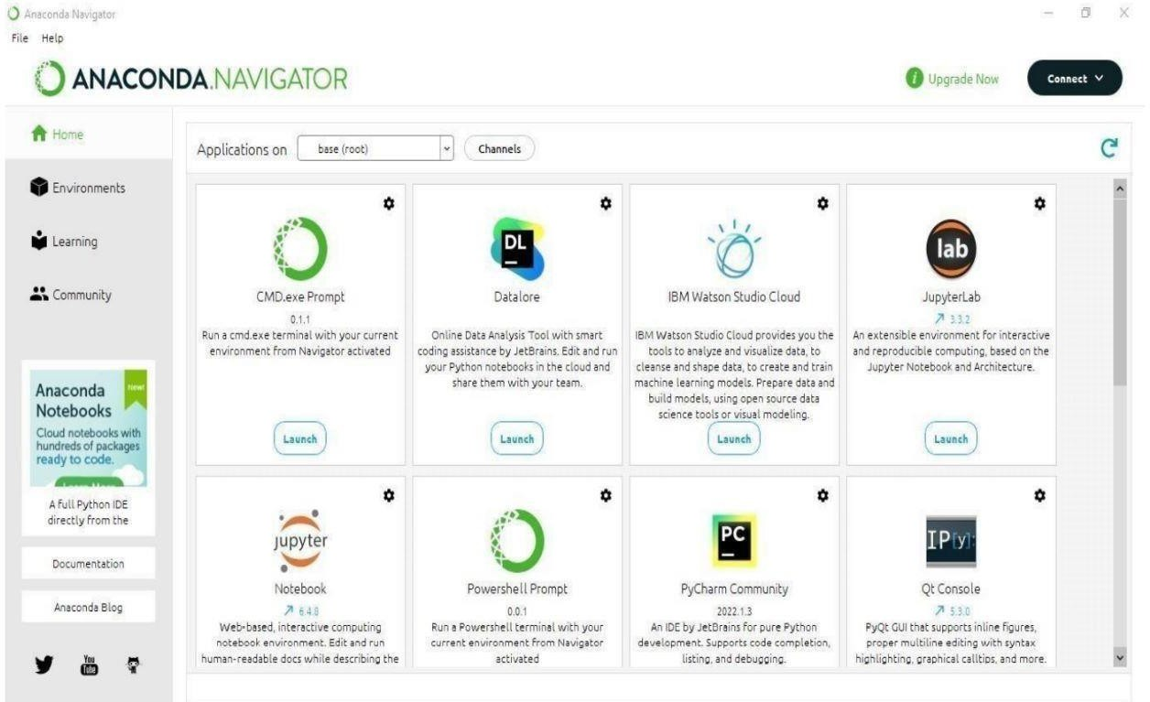**STEP 7**: Successfully **Installed** and check whether the Anaconda Navigator is working or not.